 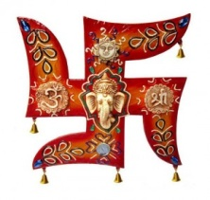 **YOUR TRAVEL ADVISER!!!!!!**

……………………………………………………………………………………………………………………………………………………………………………………………………

**BHUTAN: THE LAND OF THUNDER DRAGON**

**PACKAGE NAME: - BHUTAN AT GLANCE**

**DESTINATION: - 2N THIMPHU, 2N PUNAKHA,2N BUMTHANG, 1N PHOBJIKHA, 3N PARO**

**DURATION: - 10 NIGHTS /11 DAYS**

**PICK UP AND DROP: - PARO INTERNATIONAL AIRPORT**

**HOTEL SINGYE - THIMPHU**

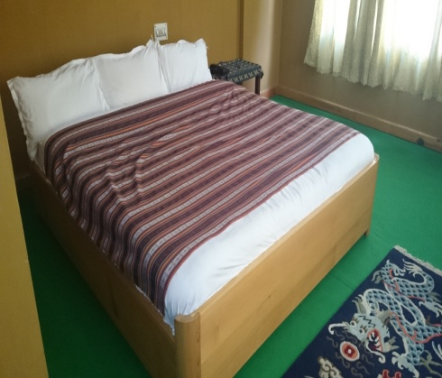 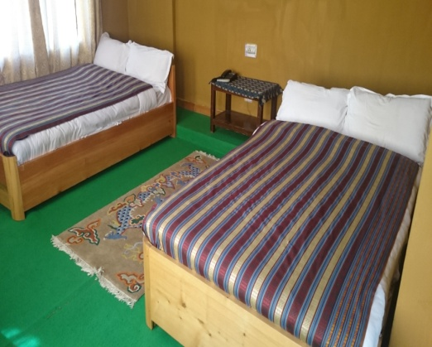 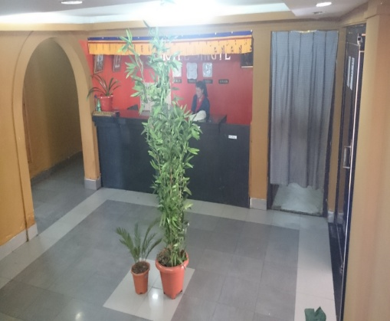

**HOTEL SAMBHAV-THIMPHU**

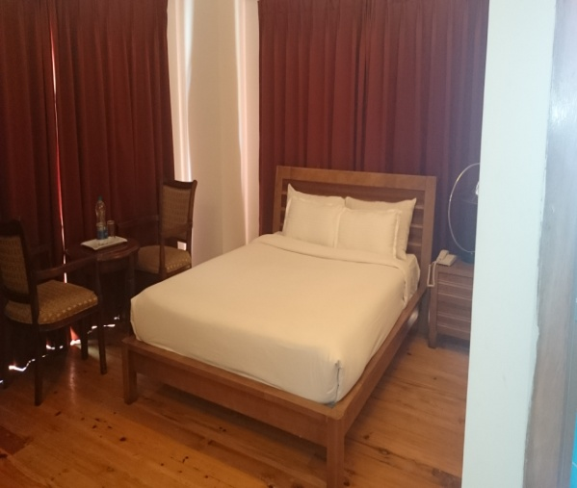 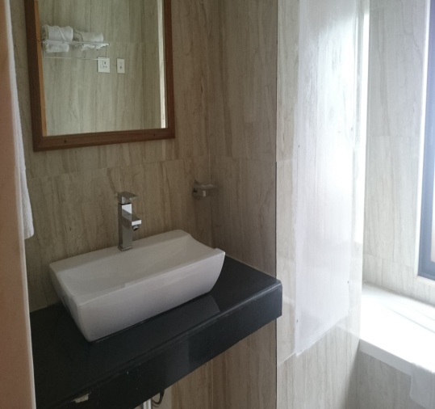 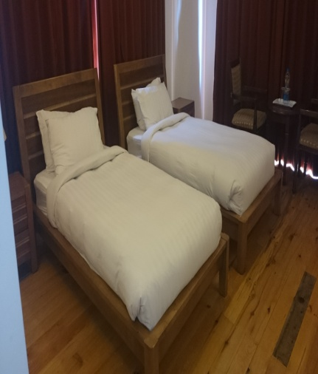

**HOTEL SONAM TROPHEL – PARO**

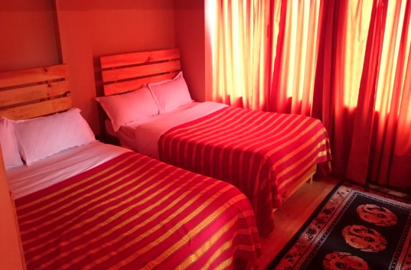 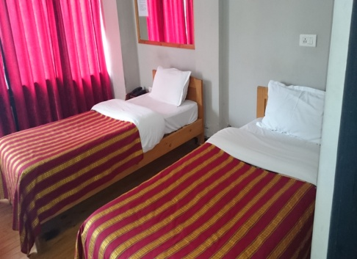 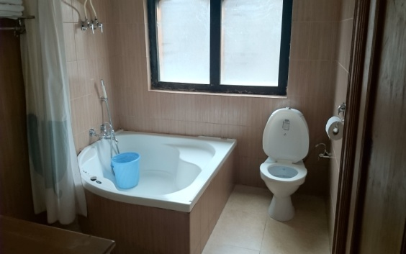

**HOTEL CITY – PARO**

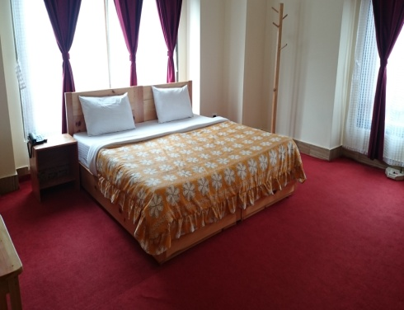 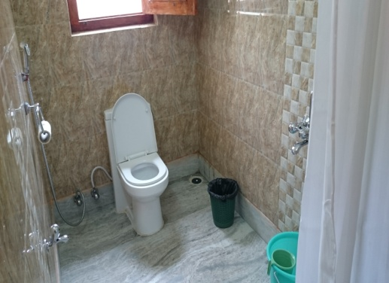 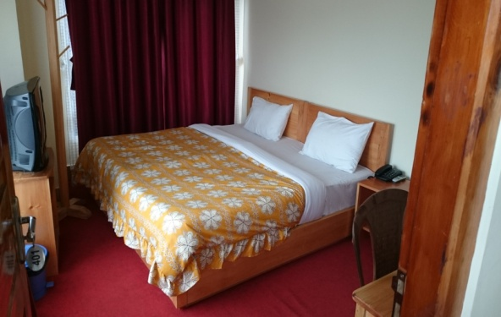

**HOTEL KINGALING – PUNAKHA**

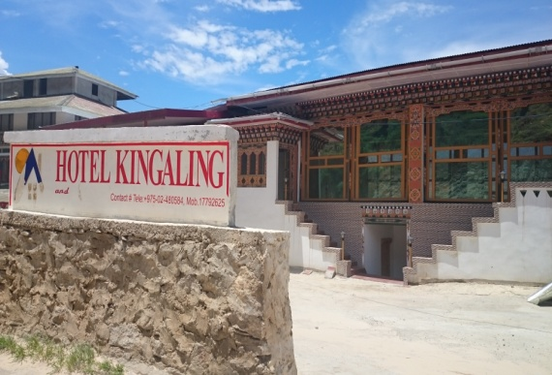 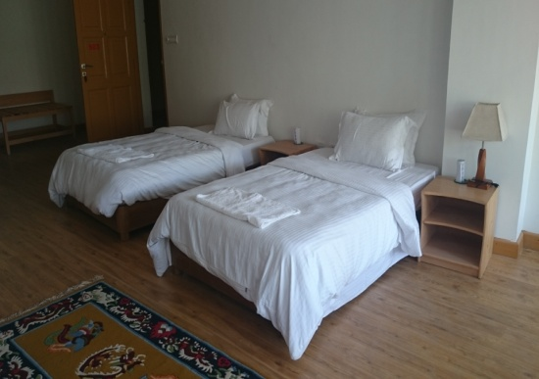 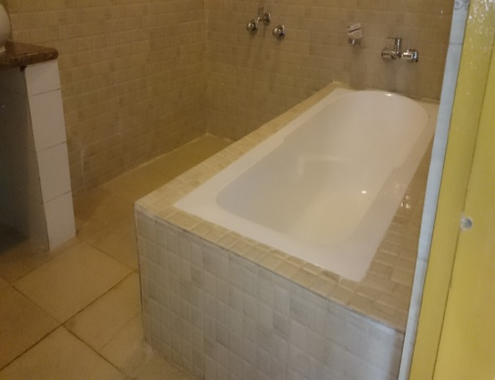

Bhutan:-

A country resting peacefully in the lap of eastern Himalayas is one of those very few places that can probably take you back in time. The unadulterated nature, around 73% of the land drenched in wild greenery, the flag with dragon engraved on it, the rice that is born red, the place which is believed to be haunted by multiple demons and protected by multiple gods, the innocence of the locals that still believe that snowman exists and dragons spit fire, the land that has preserved the rarest of the nomadic tribes and fauna on the list of ‘red-alert’ is what Bhutan is made up of. Not very well known amongst the tourist crowd, Bhutan indeed offers some mystical, magical places to visit for the intrepid traveler.

**DAY 01: ARRIVAL AT PARO AIRPORT – TRANSFER TO THIMPHU**

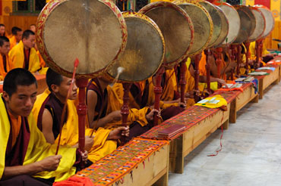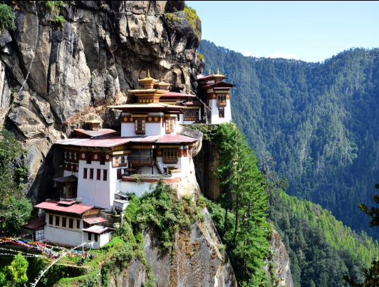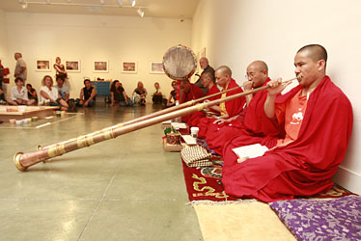

Meet & Greet on arrival at Paro Airport and transfer to Thimphu (7,710 ft.) the capital city of Bhutan. On arrival check in at the hotel. Afternoon start for half day Thimphu sightseeing consist of **Kuensel Phodrang** (Buddha Statue) a place for refreshing with a huge statue of Buddha on the top of the Kuensel Phodrang, **King's (National) Memorial Chorten**  - This Chorten was built in 1974 in a typical Tibetan style. It is also a center of worship for the people living in Thimphu. **Tashichho Dzong** (Fortress of the Glorious Religion) - The Dzong is the seat of the national government and the Central Monastic Body, including the summer residence of the Je Khenpo (Chief Abbot of Bhutan) at present. & **Folk Heritage Museum**. Overnight stay at Thimphu.

**DAY 02**: **THIMPHU CITY TOUR**

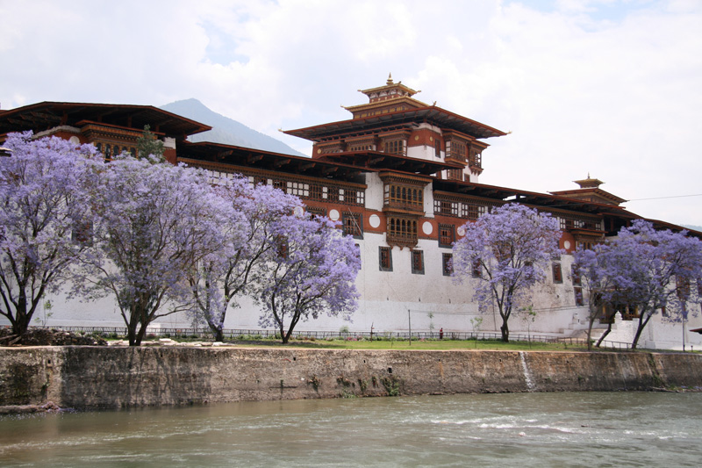 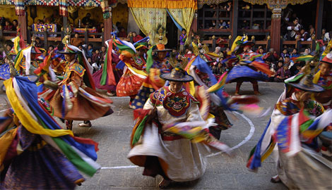

After breakfast go for morning sightseeing- visit the Indigenous hospital where traditional old art of healing is still practiced, Art & craft School, National Library, royal goldsmith workshop and handicraft centers. Have a sumptuous lunch.In the afternoon visit the Memorial Chorten built in the memory of the late king Jigme Dorji Wang chuck, 15th century

Changangkha monastery, Motithang mini zoo to see the rare “Takin” national animal of Bhutan and drive further down with good view of the Thimphu Valley. Visit the new Drupthob nunnery temple. Evening at your own leisure. Overnight in Thimphu.

**DAY 03:** **EARLY MORNING TRANSFER TO WANGDUE/PUNAKHA VIA DOCHU LA**  **PASS**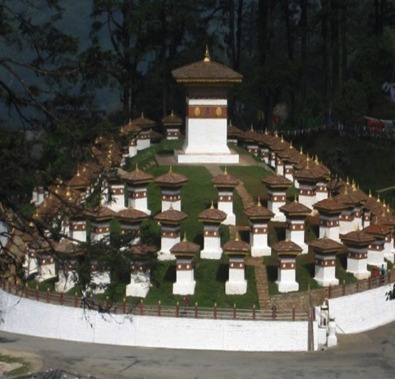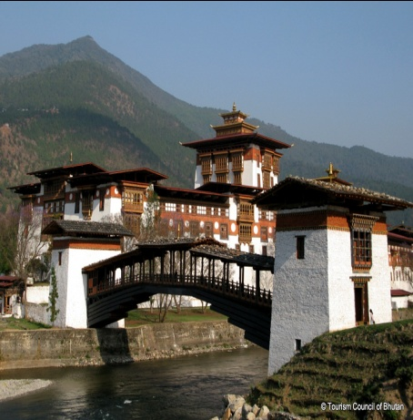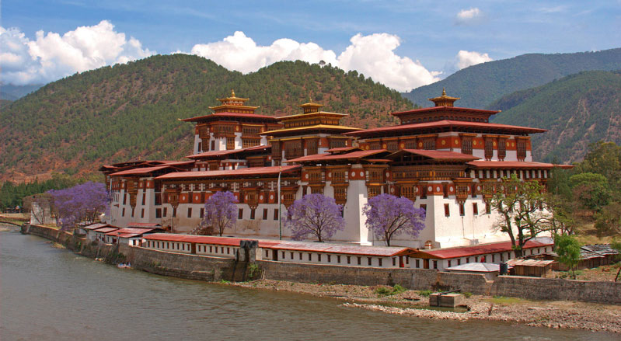

After early Breakfast, check out from Hotel & Transfer Wangduephodrang, (70 Kms/2hrs), with a stop en route for tea at Dochu LA pass (3,100 meters), where on a clear day you can get spectacular views of the Himalayans. In Wangdue, stop at Mehsina village & visit Chime lhakhang – the Temple of fertility built in 15th century by Lama Drukpa Kinley. (This monk is popularly known as the Divine Madman for his philosophy, “Salvation through Sex”), Chendebji chorten, Wangduephodrang Dzong, Phobjikhs valley on the same slope overlooking the valley is the Gangtey Gompa. Have your lunch in your way at restaurant and in afternoon drive to Punakha, the former capital of Bhutan, and visit Punakha Dzong, which is noteworthy both for being one of the most beautiful dzongs in Bhutan and also for having been built by the first Shabdrung in 1937. Overnight in Punakha.

**DAY 04:** **TRANSFER TO BUMTHANG**

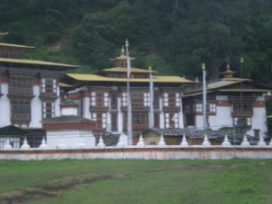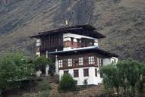

After Breakfast: Transfer to Bumthang, Switzerland of Bhutan, (which is Approx 212 Km/ 8 Hours) .Bumthang consists of the four mountain valleys of Ura, Chumey, Tang and Choekhor ("Bumthang"), Bumthang directly translates as "beautiful field" & Overnight Stay at Bumthang.

**DAY 05**: **BUMTHANG CITY TOUR**

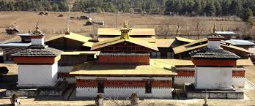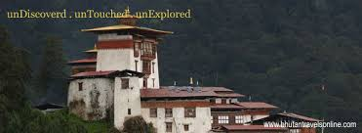

After Breakfast: Visit: 1) Mebar-Tsho (Burning Lake), 2) Kurje Monastery, 3) Jakar Dzong, 4) Jambay Lakhang, 5) Tamshing, 6) Koenchog SumLakhang, 7) Jakar Lhakhang, 8) Wangdue Choling & Overnight Stay.

**DAY 06:-BUMTHANG TO GANGTEY/PHOBJIKHA(190KM.7 HOURS DRIVE)**

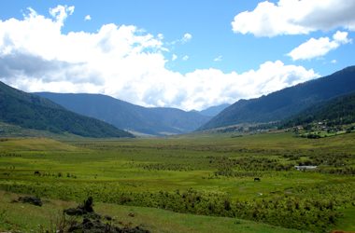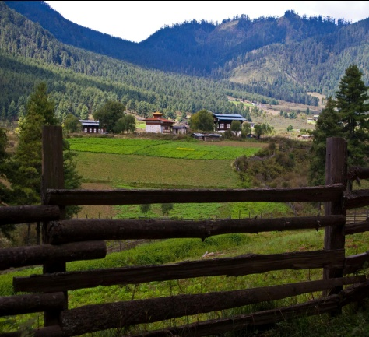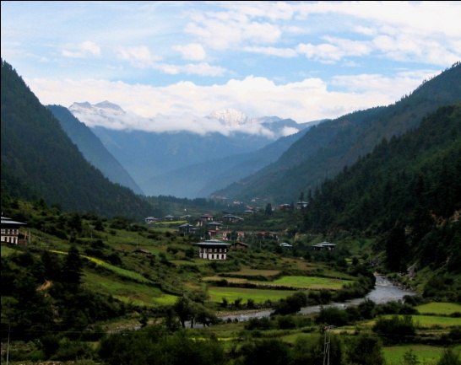

After breakfast drive to Gangtey / Phobjikha. In the mountains east of Wangduephodrang liesthe beautiful Phobjikha valley, on the slopes of which is ituated the great monastery of Gangtey, established in the 17th century. The village of Phobjikha lies a few km, down from the monastery, on the valley floor. This quite, remote valley is the winter home of black necked cranes, which migrate from the arid plains of Tibet in the north, to pass the winter months in a milder climate. Explore Gangtey village and Phobjikha valley.  
  
Overnight at the lodge in Gangtey / Phobjikha.

**DAY 07**: **TRANSFER TO W / DUE OR PUNAKHA**

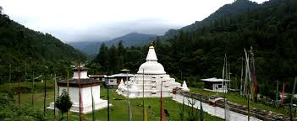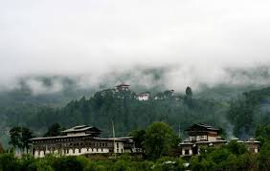

AFTER BREAKFAST TRANSFER TO WANGDUE AND NIGHT STAY AT WANGDUE.

**DAY 08: TRANSFER TO PARO**

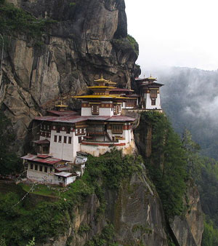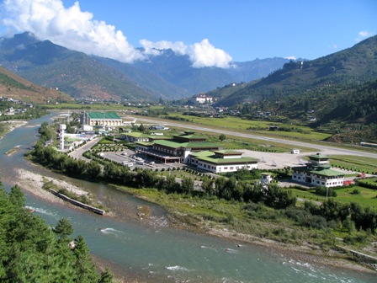 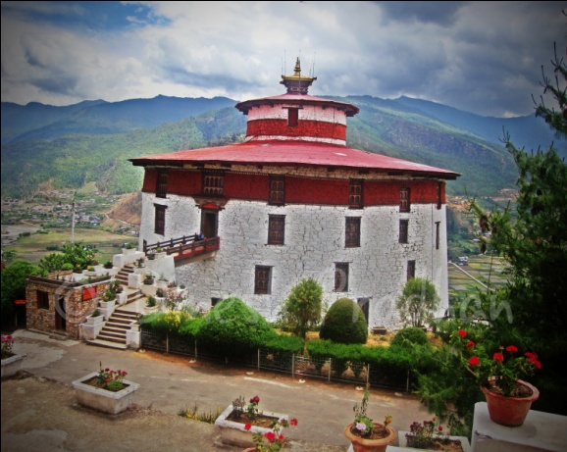

After Breakfast, check out from Hotel & Transfer to Paro. Paro is Destination of Scenic beauty, the only International airport of Bhutan in Paro. It has a population of 39,800 (which is approx 1 and half hours/65 KM from Thimphu). – visit the historic ruins of the Drukgyal Dzong, built in 1647. Paro’s Main street features shops on both sides, all crammed with brasswares, silk and cotton scarves, incense sticks, silver filigree jewellery, gho (Bhutanese National Dress for Men) which can be matched with elaborately embroidered boots, kira (wrap-around sarong worn for Bhutanese Women) and prayer flags that one could string across any open space to seek blessings for loved ones and friends. Evening at your own leisure. Overnight in Paro.

**DAY 09: PARO CITY TOUR**

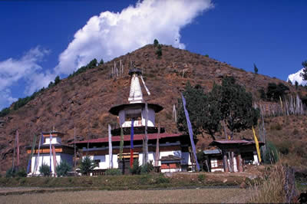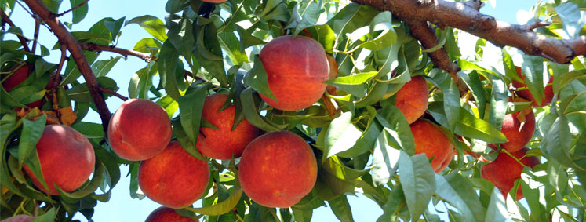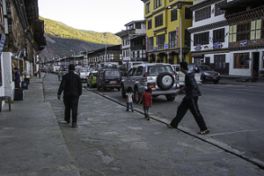

After Breakfast: Visit -1) View of Taktshang Monastery, 2) Kichulanka Monastery, 3) Ta Dzong, 4) Paro Rinpung Dzong (Museum), 5) Nya-mey Zam, 6) Dungtse Lhankhang, 7) Kila Gompa, 8) Druk Choeding. In Evening: Stroll Through the Market of Paro & Overnight Stay in Paro.

**DAY 10: CHELE LA PASS & HAAVALLEY**

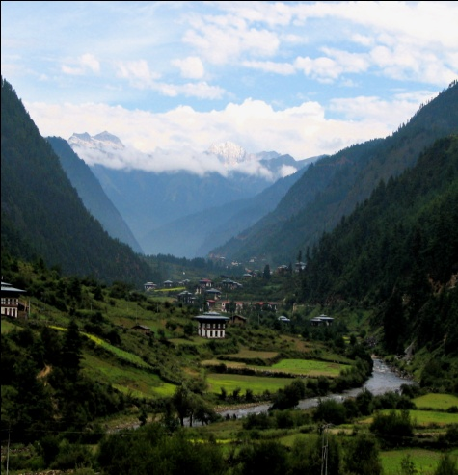 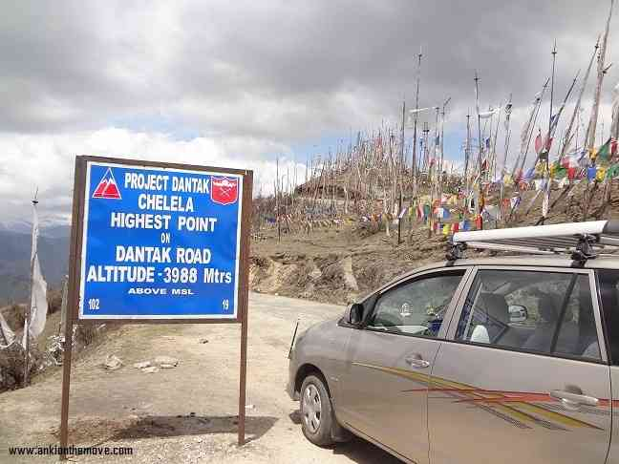 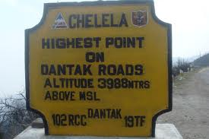

After Breakfast: Excursion To PARO Extra Point: Chele La (Pass) & Haa Valley Only (Border of the Bhutan and China):  At an elevation 3,988 meters is considered to be one of the highest motorable passes in Bhutan. About an hour's drive along a thickly-forested road, is this Pass-a botanical paradise. The pass provides stunning views of the sacred mountain Jhomolhari and Jichu Drake. It is also marked by hundreds of prayer flags fluttering in the wind. Here, visitors can see cascades of wild roses; purple and yellow primulas; and swathes of deep blue iris covering the forest floor. The top of the pass bloom with rhododendrons in a variety of colors-pale pink, deep pink, burnt orange, mauve, white and scarlet. In Evening: Stroll Through the Market of Paro& Overnight Stay at Paro.

**DAY 11: TRANSFER TO PARO AIRPORT**

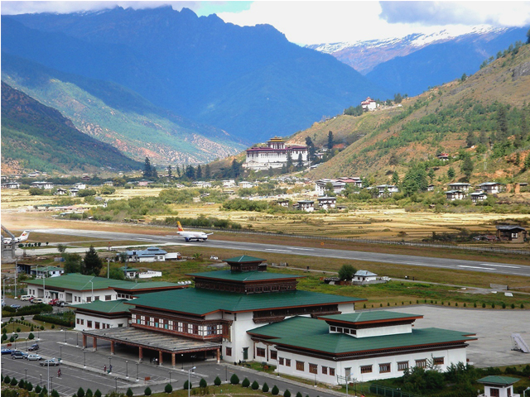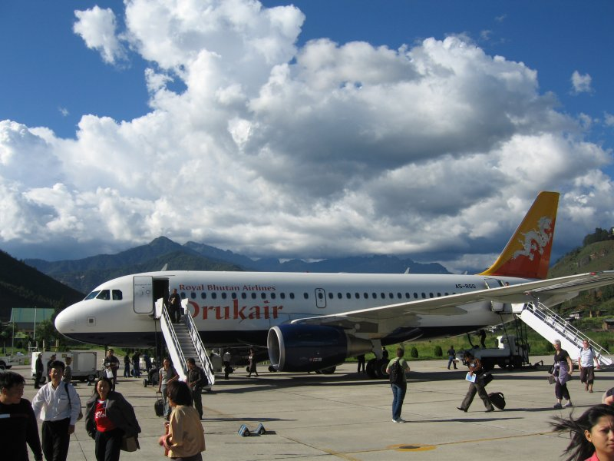

After breakfast check out from Hotel proceeds to Paro Airport for your onwards journey.

**SIGHTSEEING PLACES IN BHUTAN**

**IN THIMPHU**

Thimphu is the capital of Bhutan and the largest town in Bhutan. It lies at an altitude of 2400 metres. All government headquarters and centre for trade are located here. The following are the places of tourist attraction in Thimphu.

* **Trashichho Dzong**: Meaning “fortress of the glorious religion “was initially erected in 1641 and rebuilt by King Jigme Dorji Wangchuck in the 1960s. It is one of the largest Dzong in Bhutan. The Dzong houses the throne room and office of his majesty and is the seat of government and religious affairs in the kingdom. The northern portion of the Dzong has the summer residence of the central monastic body and his holiness the Je Khenpo (chief abot). It is open to visitors only during the Thimphu Tsechu (held in autumn) and during winter when the monk body moves to punakha.

* **National Memorial Chorten**: this monument was built in 1974 in the memory of the late King Jigme Dorji Wangchuck. It was originally the idea of Bhutan’s third King, H.M. Jigme Dorji Wangchuck to erect a monument for world peace and prosperity, but could not be done due to his untimely death. So after his death, it was built to in his memory and to serve as a monument for world peace.
* **Simtokha Dzong**: built in 1627, it is the oldest Dzong in the country. The most noteworthy artistic feature of this Dzong is the series of over 300 finely worked slate carvins behind the prayer wheels in the courtyard which are centuries old the paintings inside this Dzong are believed to be some of the oldest and the most beautiful in the country.
* **National library**: The National Library was established in the late 1960s and it houses an extensive collection of Buddhist literature mostly in block-printed format and some works are several hundred years old. There is also a small collection of books in English on the ground floor mainly on Buddhism, Bhutan, the Himalayan region and neighboring countries.
* **Institute for Zorig chusum**: commonly known as the painting School is an institute established primarily to preserve and promote Bhutan’s unique artistic tradition which played a vital role in moulding its distinct heritage. The Institute offers a six year course on the 13 tradition arts and crafts of Bhutan and on a visit one can see students learning the various skills taught at the school.
* **National Institute of Traditional medicine**: The Institute was established in 1967 as a center for indigenous medicines and practice. In olden times. People primarily relied on the indigenous medicines to cure their illness. The Institute also serves as a training school for traditional medicine practitioners. The complex is closed to visitors due to considerations of hygiene, but one can still walk around and view it from outside.
* **Buddha Point (Kuensel Phodrang)**: Located at a short drive from Thimphu city centre, visitors can get a good overview of the Thimphu valley from the Buddha point (Kuensel Phodrang). You can pay your obeisance and offer prayers to the Buddha, the largest statue in the country and then walk around and take a glimpse of the valley.
* **Botanical Gardens, Serbithang**: Located on lush hillside about 10km from the city, the gardens offer a peaceful and relaxing environment to spend a few hours. Botanists will find the wide selection of indigenous trees and plants of interest.
* **Coronation Park**: Located on the banks of the river (near the city stadium), these 5.6 acres of parkland offer a pleasant and relaxing environment to stroll or to sit and watch the river flow by.
* **The Folk Heritage Museum (Phelchey Toenkhyim):** It is dedicated to connect people to the Bhutanese rural past through exhibits, demonstrations, educational programmes and documentation of rural life. The principal exhibit in the museum is a restored three storey traditional rammed mud and timber house, which dates back to the mid 19th century. The design and form of house is that of an average household in the Wang area during that era. The age of structure demonstrates the durability and performance of the building materials. From ground to top floor, household objects, typical domestic tools and equipments that would have been used by a family during that period are put on display. The museum is also developing some of the native trees and plants that were used for various domestic purposes in the rural households.
* **Weekend Market**: Every Saturday and Sunday most of Thimphu's scant population and many valley dwellers congregate on the banks of the river where weekend market is held. It is an interesting place to visit and provides opportunity to mingle with the local people.

**IN PARO**

Paro (alt. 2200m/7218ft) - The beautiful valley of Paro encapsulates within itself a rich culture, scenic beauty and hundreds of myths and legends. It is home to many of Bhutan's oldest temples and monasteries, National Museum and country's only airport. Mount. Chomolhari (7,314m) reigns in white glory at the northern end of the valley and its glacial water plunge through deep gorges to form Pa Chhu (Paro River). Paro is also one of the most fertile valleys in the Kingdom producing a bulk of the locally famous red rice from its terraced fields.

Places of interest in and around Paro:-

* **Rinpung Dzong**: Built in 1646 by Shabdrung Ngawang Namgyal, the first spiritual and temporal ruler of Bhutan, the Dzong houses the monastic body of Paro, the office of the Dzongda (district administrative head) and Thrimpon (judge) of Paro district. The approach to the Dzong is through a traditional covered bridge called Nemi Zam. A walk through the bridge, over a stone inlaid path, offers a good view of the architectural wonder of the Dzong as well as life around it. It is also the venue of Paro Tshechu, held once a year in the spring.
* **Ta Dzong**: One time watch tower built to defend Rinpung Dzong during inter-valley wars of the 17th century, since 1967 Ta Dzong is serving as the National Museum of the country. It holds fascinating collection of art, relics, religious thangkha paintings and Bhutan's exquisite postage stamps. The museum circular shape augments its varied collection displayed over several floors.
* **Drukgyel Dzong**: This Dzong, with a delightful village nestling at its foot, was built in 1646 by Shabdrung Ngawang Namgyal to commemorate his victory over the Tibetan invaders. Historically and strategically this Dzong withstood all its glory and was featured in 1914 vide National Geographic magazine. The glory of Drukgyel Dzong remained even when it was destroyed by fire in 1951. On a clear day, one can see the commanding view of Mount. Chomolhari from the village, below the Dzong.
* **Kyichu Lhakhang**: It is one of the oldest and most sacred shrines of the Kingdom dating back to 7th century (the other is Jambey Lhakahng in Bumthang). The lhakhang complex is composed of two temples. The first temple was built by Tibetan King, Songtsen Gampo in the 7th century and in 1968, H.M. Ashi Kesang, the Queen Mother of Bhutan, built the second temple in original pattern.
* **Dungtse Lhakhang**: To the west of the road is Dungtse Lhakhang, a chorten-like temple. This unusual building was built in 1433 by the iron bridge builder Thangtong Gyalpo. It has three floors representing hell, earth and heaven and the paintings inside are said to be some of the best in Bhutan.   
    
  Beyond Dungtse Lhakhang, to the east of the road, the tiny Pana Lhakhang is quite old and is believed to have been built in the seventh century.

**In punakha**

Punakha (alt. 1300m/4265ft) - Punakha served as the capital of Bhutan until and still it is the winter seat of Je Khenpo (the chief abbot). Blessed with temperate climate and owing to its natural drainage from Pho Chhu (male) and Mo Chhu (female) rivers, the Punakha valley produces abundant crops and fruits. There are splendid views of the distant Himalayas at Dochula pas (alt. 3,050m) on Thimphu – Punakha road.

Places of interest in and around Punakha

* **Punakha Dzong**: Built strategically at the junction of Pho Chhu and Mo Chhu rivers in 1637, by Shabdrung Ngawang Namgyal to serve as the religious and administrative centre of the region, Punakha Dzong has played an important role in Bhutan's history. Damaged by four catastrophic fires and an earthquake, the Dzong has been fully restored by the present King. The Dzong is open for visitors during Punakha festival and in summer months when the monk body moves to Thimphu.
* **Khamsum Yulley Namgyal Chorten**: A beautiful hike takes one to the regal Khamsum Yuelley Namgel Chorten, which was built to remove negative forces and promote peace, stability and harmony in the changing world. The Chorten dominates the upper Punakha Valley with commanding views across the Mo Chhu and up towards the mountainous peaks of Gasa and beyond.

INCLUSION

* 4 NIGHTS ACCOMODATION IN 5 STAR,4 STAR, 3 STAR, DELUX & STANDARD HOTELS
* TRANSFER ALL IN PRIVATE IN 4 SEATER (WAGONR/SANTRO),7 SEATER (INNOVA /XYLO), 8 SEATER (BOLERO/TAVERA/SCORPIO/TATA SUMO)
* SIGHT SEEN AS PER ITINERARY
* IMMIGRATION CHARGES
* DRIVER CUM GUIDE
* PICK UP AND DROP FROM PARO INTERNATIONAL AIRPORT
* FOOD AS PER CP(BREAKFAST ONLY)
* VEHICLE WILL BE PROVIDEDPOINT TO POINT AND NOT AT DISPOSAL

EXCLUSIONS

* Extras of personal nature such as personal tips, laundry charges, additional tour charges.
* Does not include any Lunch, Evening Tea/snacks & dinner
* Insurance, Medical & Emergency rescue costs.
* Does not include Hard DRINKS OR liquor or mineral water or soft drinks/juices.
* Does not include Entrance Fees at Monasteries / Monuments / Museums etc.
* Does not include specialized Guide
* AIR FARE / TRAIN FARE
* ANY OTHER ITEMS NOT MENTIONED IN COST INCLUDES

HOW TO BOOK

Just pay 25 % of the package cost inclusive of taxes and full amount of the airlines cost. You will get a booking confirmation voucher within 240 minutes of the payment receipt and your booking status will be "**BOOKING HOLD- CONFIRMED**"

* Please do not forget to send one email to rstravels86@gmail.com  
  post payment mentioning your reference number. If you do not get voucher on-time you may call us at +91-8768841510

BANK ACCOUNT DETAILS

ACCOUNT HOLDER NAME :- R S TRAVELS

BANK NAME:-UNION BANK OF INDIA

ACCOUNT NO :- 702101010050095

IFS CODE :-UBIN0570214

ACCOUNT TYPE :- CURRENT A/C

BRANCH NAME :- JAIGAON

ACCOUNT HOLDER NAME :- R S TRAVELS

BANK NAME:-STATE BANK OF INDIA

ACCOUNT NO :- 35081943112

IFS CODE :-SBIN0006278

ACCOUNT TYPE :- CURRENT A/C

BRANCH NAME :- JAIGAON

**Documents required to enter in Bhutan are:**

* Indian nationals do not require any visa for Bhutan. A permit will be issued at the entry point on production of a Passport or Voter ID and 04 Passport size photographs. We can also arrange the permit ahead of travel provided all documents are submitted 15 days prior travel to our registered office.
* **Restricted Area Permit for Punakha / Wangdue:** Restricted Area Permit is required to visit Punakha / Wangdue from Home Ministry of Bhutan. Please bring 02 passport size photographs and Voter ID card or Passport of each person including child. This special permit is given only after guest has entered Thimphu. Permit are not issued on Saturday and Sunday and Govt Holidays.
* **NOTE:**
* Above rates are for Indian National and Bangladesh National only
* For Bangladesh National double entry visa is Mandatory
* The rates quoted in the packages are on per person basis till 31st December 2015 (High seasons surcharge will be applicable during the Festivals & Peak season)
* The above mentioned hotels will be confirmed as per the room availability. Otherwise similar category hotel will be provided
* Bhutan is a smoke free country, Smoking and tobacco is strictly prohibited in Bhutan.
* The booking will be confirmed only after we receive 25% of the tour cost as advance
* Additional sightseeing or extra usage of vehicle, other than mentioned in the itinerary will be charged extra
* Children below the age of 18 can carry school/college Id card for the Permit

**PAYMENTS TERM**

* 25 % at the time of booking and balance 10 days prior travel date.
* No booking are guaranteed without advance payment and rates are subject to availability.

**CANCELLATION POLICY**

* Less than 7 days prior to Date of Travel: 100% of the package cost as cancellation charge.
* 7-15 days prior to Date of Travel: 75% of the package cost as cancellation charge.
* 16-30 days prior to Date of Travel: 50 % of package cost as cancellation charge.
* More than 30 days: Full refund of package cost excluding processing fees.

**TERMS AND CONDITIONS**

* R.S travels reserves the right to re- arrange itinerary to suit hotel availability without changing the hotel number of days in each destination and without compromising any services.
* The vehicle used is Ac or Non Ac and is available for point to point services only and is not at disposal. Clients are requested to follow the itinerary.

**DO’S IN BHUTAN**

* Although Bhutan welcomes foreigners these days especially for those on their last minute all inclusive holidays, the country is extremely conscious regarding its culture.
* The greeting in the Bhutanese language Dzongkha for hello is Kuzu Zangpola, and says Tashi Delek for good bye or good luck.
* All the citizens, except India and Bangladesh, need VISA to enter into Bhutan.
* VISA should be applied minimum 30 days before you plan to visit Bhutan
* One need is route permits to travel in Bhutan and this is provided by the Immigration Office at Thimphu.
* Either carries Nu (Bhutan’s Currency) or INR (Indian Rupees). Both is accepted in Bhutan, though 500 and 1000 Indian rupee notes might not be as easily accepted.
* Use right hand while giving or receiving something. Pass the holy sites keeping them on your right side.
* US dollars are pretty widely accepted in Bhutan, but you are still advice to exchange some of your currency to Bhutan’s currency i.e. ngultrum (Nu) or Indian rupee for buying small items and for the really remote places. There are not many ATM machines nearby except major cities like Thimphu, where also international ATM/credit cards might or might not work.
* Do bring MasterCard- not Visa or other credit cards. Banks, ATM’s will not give cash on a Visa credit card in Thimphu or Paro and other areas as well and only a few merchants will take credit cards.

**DON’T’SIN BHUTAN**

* TOBACCO IS ABSOLUTELY PROHIBITED IN Bhutan. The tourists might use it, but extra care should be taken. Selling or giving tobacco to the locals is also a crime.
* Make sure you take off your footwear before you enter into any religious place.
* You are advised to dress discretely and modestly in Bhutan. If you’re visiting any Bhutanese temple (Tsechu), they’d admire you if you wear their national dress gho & kira. Also make some donation to Tsechu.
* Foreign nationals are not permitted to carry Indian rupees across the border to and from India.
* Buying and selling of antiques is strictly forbidden in Bhutan. Don’t jump to give toys or treats to children in exchange for photo offers. Locals are careful not to breed a generation of children who beg tourist, as happens-but adults likely will not object out loud out of politeness.

The following points are to be noted for Child rate:-

* Children above 10+ years will be charged 100% as per adult rate.
* Children of 5+ to 10 sharing parent’s room will be charged as per CWB or CNB
* Children below 5 years complimentary.

(Hotels are very strict with the child policy. Please carry the age proof so that it can be produced when asked)